Question 1
What is a variable in C/C++?

ANSWER :

In C and C++, a variable is essentially a named storage location in your computer's memory (RAM) that holds a value. Instead of remembering complex memory addresses , you give that memory space a human-readable name.

Example: int age = 20;

In this line, int is the data type (integer), age is the variable name, and 20 is the value stored inside it.
- Why do we use variables in programs?

ANSWER :
We use variables because computers track data using complex, cryptic memory addresses , which are impossible for humans to manage at scale. Variables act as human-readable labels for these memory locations, allowing a program to dynamically store, reuse, and update changing data—such as user inputs, game scores, or repeating calculation values—in a way that is easily modifiable and readable.

Here is exactly why we use them:

1. Labeling and Memorization (Readability)

2. Handling Dynamic (Changing) Data

3. Reusability and the "Change Once, Update Everywhere" Rule

4. Saving Intermediate Results
- What is the difference between a variable name and its value?

ANSWER : The difference between a variable name and its value is :

Feature | Variable Name (Identifier) | Variable Value (Data)
What it is | The label on the container. | The contents inside the container.
Who uses it | Humans (Programmers) use it to read and write code easily. | The Computer (CPU) uses it to perform calculations and logic.
Mutability | Fixed. Once you name a variable in your code (e.g., int score), that name cannot change while the program runs. | Changeable. The data inside can be overwritten at any moment (e.g., score can go from 0 to 10 to 50).
Example | In int age = 20;, age is the name. | In int age = 20;, 20 is the value.

- Which of the following is a valid variable name? a) 2num b) total_marks c) for d) my marks

ANSWER : b) total_marks
- Why is Age different from age?

ANSWER :

Age is different from age because C and C++ are strictly case-sensitive languages.
To the computer's compiler, uppercase and lowercase letters are completely different symbols with entirely different numeric values behind the scenes

- Can a variable name contain spaces? Why?

ANSWER :

No, a variable name cannot contain spaces, because The Compiler Gets Confused it elies on spaces to know where one part of your code ends and the next part begins So it parsing ambiguity
- Can a variable name start with an underscore (_) ?

ANSWER :

Yes, a variable name can absolutely start with an underscore (_). For example, int _count = 10; is completely valid in C/C++.
However, even though it is technically allowed, you should generally avoid doing it unless you have a specific.

- What happens if two variables have the same name in the same scope?

ANSWER :
If two variables have the exact same name in the same scope, the C/C++ compiler will get confused and throw a redefinition error (e.g., "conflicting declaration" or "redefinition of 'x'"). It will completely refuse to compile your program.

For Example : in C++

int marks = 85;
double marks = 92.5; // Compiler Error!
- Write three meaningful variable names for storing student information.

ANSWER :

Here are three meaningful and self-documenting variable names for storing student information, depending on the specific data you are tracking:
- studentProfile: Best for storing a nested object or comprehensive record containing a student's personal and academic details.
- studentAcademicRecord: Ideal for storing enrollment data, grades, GPA, and major.
- studentContactList: Perfect for storing or iterating through an array of student communication details (emails, phone numbers, and addresses).

- Which naming convention is better and why: studentMarks or sm?
ANSWER:
Both are technically valid and will compile exactly the same way while studentMarks is significantly better than sm because it has Readibility and clarity also easier code maintenance

- What is a data type?
ANSWER :
In C/C++, a data type (or datatype) is an attribute that tells the compiler two critical things about a variable: how much memory to allocate for it, and what kind of values it is allowed to store.
Whenever you create a variable, the system needs to know if it should prepare a small container for a single letter or a larger container for a complex fractional number.
Data types are generally divided into three main categories:
- Primary/Built-In Data Type – (int, char, etc.)
- Derived Data Type – ( Arrays, Pointers)
- User defined Data Type – (Struct, class)

- Which data type is used to store whole numbers?

ANSWER :
The primary data type used to store whole numbers in C/C++ is int (short for integer).
It is used for numbers that do not have any fractional or decimal parts, and it can store both positive and negative values.
Ex- int rollNumber = 45;
int temperature = -5;

- Which data type is used to store decimal values?
ANSWER :
In C/C++, there are two primary data types used to store decimal values (fractional or floating-point numbers):
- float (Single Precision): Typically uses 4 bytes of memory and gives you about 6 to 7 digits of decimal precision. When assigning a value, you usually append an f to the end of the number. Ex - float weight = 65.5f;
- double (Double Precision): Typically uses 8 bytes of memory and provides about 15 to 17 digits of decimal precision. This is the default type for decimal numbers in C/C++.
Ex - double pi = 3.141592653589793;

- What is the difference between float and double
Ans) The difference between float and double:

Feature | float (Single Precision) | double (Double Precision)
Memory Size | 4 bytes (32 bits) | 8 bytes (64 bits)
Precision | 6 to 7 decimal digits | 15 to 17 decimal digits
Suffix Required | Yes. Must end with an f or F (e.g., 3.14f). | No. It is the default for decimals (e.g., 3.14).
Use Case | Graphics, gaming, or systems with low RAM. | Financial calculations, physics simulations, defaults.

- Which data type stores a single character?

ANSWER :
The data type used to store a single character in C/C++ is char.
It occupies exactly 1 byte of memory and must always be enclosed in single quotes (e.g., 'A', '7', or '$').
Ex- char grade = 'A';
char symbol = '#';
- Which data type stores True/False values?

Answer :

The data type used to store true or false values is bool (short for Boolean).
It represents a logical entity and can only hold one of two states: true or false.
Ex - bool isPassed = true;
bool isRaining = false;

- What data type is suitable for storing a person's name?

ANSWER :
To store a person's name, the most suitable data type is std::string in C++ (or a character array/pointer char[] in standard C).

Ex – In c++ Ex – IN C
#include <iostream> #include <stdio.h>
#include <string> // Required header int main() {
//Reserve space for upto 49 characters + 1 invisible null terminator (\0)
int main() { char personName[50] = “Rajyavardhan”;
std::string personName = "Rajyavardhan";
printf(“The name is : %s”, personName);
std::cout << "The name is: " << personName; return 0;
return 0; }
}
- Predict the output: int age=18; cout<<age;

Output :

18
- Identify the data type: 25, 3.14, 'A', true.

Answer :

• 25 -int (Integer, used for whole numbers)
• 3.14 -double (Double-precision floating-point, the default type for decimal values; if written as 3.14f, it would be a float)
• 'A' -char (Character, used for a single letter wrapped in single quotes)
• true -bool (Boolean, used for logical true/false states)

- What happens if you store a decimal number in an int variable?
Answer :
If we store a decimal number in an int variable, C/C++ will perform a process called truncation.
The compiler will completely chop off the decimal part (everything after the dot) and store only the whole number. It does not round the number up or down.
Example :
int number = 5.99;
std::cout << number;

output: 5
- What is the purpose of cin?

Answer :
In C++, cin stands for "Character Input" and its primary purpose is to read data from the standard input device, which is almost always the user's keyboard.
- What is the purpose of cout?

Answer :
In C++, cout stands for "Character Output" and its primary purpose is to display data to the standard output device, which is almost always your computer screen or console window.
- Which symbol is used with cin?
Ans:
The symbol used with cin is >>.

- Which symbol is used with cout?

Ans:
The symbol used with cout is <<
- Explain: cin >> age;

Answer:
The statement cin >> age; is used in C++ to get input from the user via the keyboard and store it inside a variable named age.
- Explain: cout << age;

Answer:
The statement cout << age; is used in C++ to display or print the value stored inside a variable named age onto the computer screen (the console).
- What is the purpose of endl?

Answer :
endl is used to move the cursor to the next line and immediately flush the output stream.
Example :
#include <iostream>
using namespace std;

int main() {
cout << "Hello" << endl;
cout << "World";
return 0;
}
Output : Hello
world

- Write a statement to input a student's marks.

Answer :
declaring a variable to store the marks, and using the cin statement to accept the input from the keyboard.

int studentMarks;
std::cin >> studentMarks;
- Write a statement to display 'Welcome to C++'.

Ans:
std::cout << "Welcome to C++";
- Predict the output: cout << “Programming”;

Output:
Programming
- What is an operator?

Answer :
An operator is a special symbol or keyword that tells the compiler to perform a specific mathematical, logical, or relational manipulation on data.

- Which operator is used for addition?
Answer :
The operator used for addition is +.

- What is the result of 10 % 3?

Ans: 1
The % symbol is the modulus operator, which calculates the leftover remainder after a division.
- What is the result of 8 % 2?

Ans : 0
- Which operator checks equality?
Answer :
==

- What is the difference between = and == ?

Answer :
Feature | = (Assignment Operator) | == (Equality Operator)
Purpose | Used to assign or copy a value on the right side into a variable on the left side. | Used to compare two values to check if they are identical.
Action | It changes the value of the variable on the left. | It does not change any values; it only inspects them.
Result | Evaluates to the value that was assigned. | Evaluates to a boolean value: either true ($1$) or false ($0$).
Direction | Value moves right-to-left ($\leftarrow$). | Compares both sides side-by-side ($\leftrightarrow$).

- What is the result of 5 > 3?

Answer :
The result of 5 > 3 is true
- What does && represent?

- What does || represent?

- What does ! represent?

- Write a program to print 'Hello World'.
Ans :

#include <stdio.h>
int main() {
printf("Hello World\n");
return 0;
}

Output :

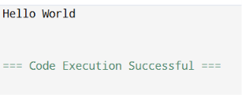
- Write a program to input two numbers and display their sum.
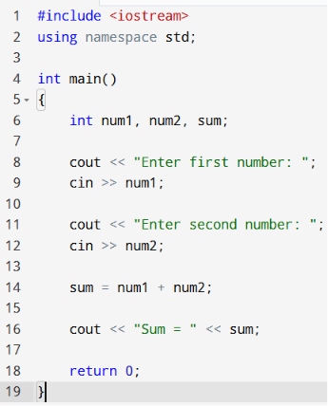 output : 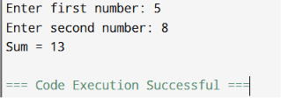

- Write a program to calculate the area of a rectangle.
Code :
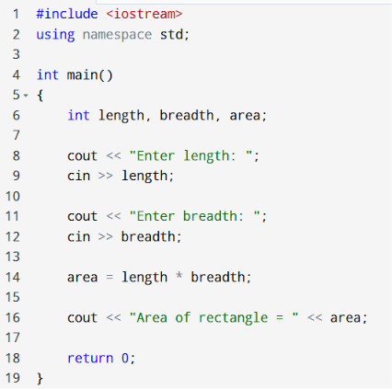 output : 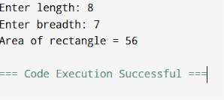

- What formula is used to calculate Simple Interest?
Answer :
The formula used to calculate Simple Interest (SI) is:
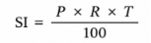
Where:
- P = Principal amount
- R = Rate of interest (per annum)
- T = Time (in years)

- Write a program to calculate Simple Interest.
Code :
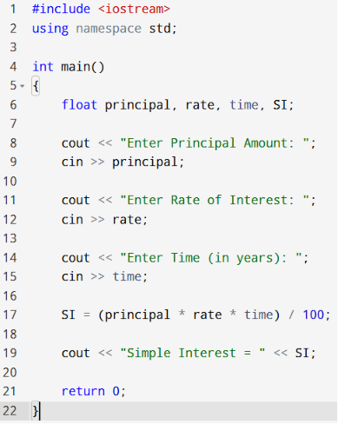 Output : 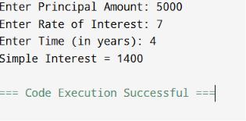
- Why is a temporary variable used while swapping two numbers?
Answer :
A temporary variable is used while swapping two numbers to store the value of one number temporarily so that its value is not lost during the exchange.
- Swap the values: a=10, b=20.
Code :
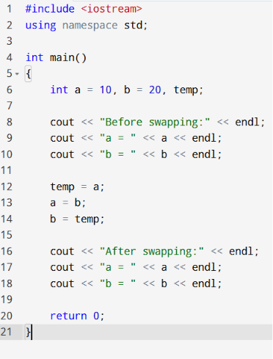 Output : 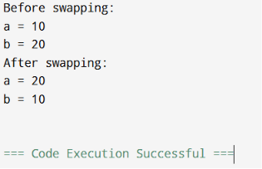
- What formula is used to convert Celsius into Fahrenheit?
Answer :
The formula used to convert Celsius (°C) into Fahrenheit (°F) is:
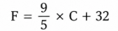

Where:
- F = Temperature in Fahrenheit
- C = Temperature in Celsius

- What is the Fahrenheit value of 0°C?

Answer :
The Fahrenheit value of 0°C is 32°F.

- Why can integer division give incorrect results in the Celsius-to-Fahrenheit program?
Answer :
Integer division can give incorrect results because it discards the decimal part, leading to inaccurate temperature conversions.

F = (9 / 5) * C + 32; // Wrong

F = (9.0 / 5) * C + 32; // Correct

